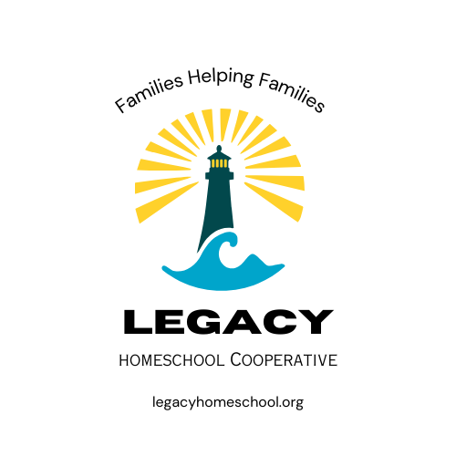
ABOUT US

Our Vision:

As homeschooling families, we are coming together in friendship and learning. This is achieved by creating an uplifting and respectful environment with a variety of classes led by parents. We believe there is value in many philosophies of learning and curriculum. We strive to enhance, not replace what we are learning in our individual homes, as we are stewards over our own families.
At Legacy, we strive to be like a lighthouse. A place of safety, strength, hope and direction. We can help uplift and encourage each other by sharing our light!
Member Information:
-We meet at the Whittier Center on Tuesdays from 10am-3pm.
*Eligibility-Must have one or more 12–18-year-old children in your family attending to join or teach teens.

All will:
1. Teach/help in the classes you’re assigned to.
2. Abide by all policies and procedures.
3. Follow all standards of conduct.

Legacy Crew

CAPTAINS:
Emily Stoker Jessicca Martin
GUIDES: All parents/teachers
NAVIGATORS: Teens 12-18 (Can be 11 turning 12 this school year- September-April, if ready for teen classes)
EXPLORERS: Children 8-11 (Can be 12 if prefer to be in this group)
-JR. EXPLORERS: 5-7 LITTLE LIGHTS: 0-4
Meet your Co-Captains-
We Love God and We Love Others. We look to God for direction in our lives. We value the family as the fundamental unit of society.
We honor the Legacy of our families, mentors, pioneers and our country's founding fathers. In them we find inspiration, wisdom and values to help guide our children and leave our own Legacy.
Meet Jessicca:
I grew up in the Northwest and I have loved raising my family here in northern Utah. I like to read and play games. My husband Wade and I have 6 children and now a son- and daughter-in-law as well. I have appreciated the opportunity to homeschool for the past 14 years and enjoy the community of other homeschool families. I loved starting and helping with other co-ops. I am excited for Legacy cooperative so my youngest children can benefit from us gathering as homeschool friends.

Meet Emily:
I found my love for nature and the outdoors from growing up in the Pacific Northwest. My husband Aaron and I love living in beautiful Cache Valley with our 5 children. We have been homeschooling for the past 10 years and it has been a blessing to our family. We love and appreciate our homeschool community! We have thoroughly enjoyed putting on teen dances and events for the past 4 years and will continue to. Since starting our homeschool journey, I have loved teaching a variety of classes at co-ops and educational groups. I am looking forward to coming together with other families to create a place of learning, support, and friendship.

Compass of Learning
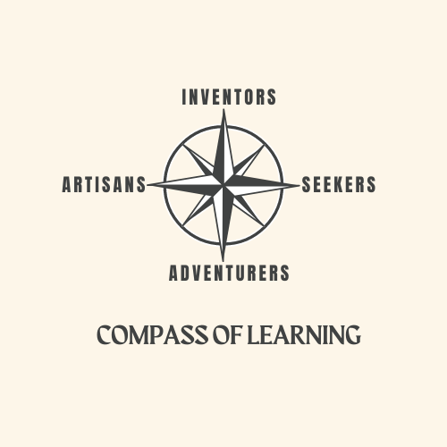
We have listed some examples of possible classes. There are many more possibilities, and many can fit in more than one compass points. Inventors: ex. Science, Tech, Math, Engineering, Architecture, Robotics, Business, Lego or Building Challenges, etc.

Seekers: ex. History, Geography, Writing, Constitution, Debate, language, Literature, Sociology, Life Skills etc.

Artisans: ex. Arts & Crafts, Drama, Sewing, Music, Cooking, Painting, Drawing, Photography, Interior Design, etc.

Adventurers: ex. PE, Health & Fitness, Dance, Survival Skills, Board Games, 4-H, etc.

Our desire for our children is that Guides aid in helping them Navigate and Explore through their own education and life experiences. We hope to achieve this through offering a broad range of classes they can choose from. Navigators and Explorers are guided by our "Compass of Learning" by becoming Inventors, Seekers, Artisans and Adventurers for the day. The goal is to teach, and children choose to take classes from all four compass points. Everyone can contribute because we each have unique life experiences, insights, and talents to share.

We hope for engaging and interactive classes. Having activities is one way to accomplish this. As Guides, we want to encourage participation without pressure. Guides should also encourage friendship building and inclusion.

We will have at least two Guides for each class. Some classes may have Guides rotate teaching or team teaching. As Guides (teachers), be willing to communicate with parents regarding their child’s progress and behavior while in your class. Please promptly and kindly correct disrespectful behavior, or inappropriate language. We need to communicate with parents if something comes up with a child (behavior problem or injury). There might be times when you as a parent need to care for your child because of injury or misbehavior. If this is the case, step away from the class you're teaching, and the helpers will step in for you.

LEGACY GATHERING
Gathering as families is an important part of Legacy Homeschool Cooperative. We highly encourage ALL to attend. This is to encourage unity and friendship building within our community. This time is devoted to keeping informed with important co-op announcements, getting more acquainted, sharing our talents, and encouraging each other. This is achieved through thoughts, prayer, and the pledge of allegiance.

School Year: Sep. 2024- April 2025
September 3- Fall semester begins
*October 29- Halloween party
November 26- Thanksgiving break
December 10- Last day Fall semester (14 days of classes)
January 7- Spring semester begins
*February 11- Valentine party
February 18- Winter break
April 1- Spring break
April 22- Last day Spring semester (14 days of classes)

